AVL BST's

A unbalanced, or nearly linear, BST executes adding, searching, and removing in O(n) time. A self-balancing BST, if well-implement, can execute adding, searching, and removing in O(log² n) time. Some common self-balancing BST's include AVL trees, red-black trees, and AA trees.

AVL trees are always optimally balanced, and therefore slower. Red-black trees are less balanced, but faster. An AA tree is a red-black tree with restrictions that make the AA tree much easier to maintain.

We will implement the AVL algorithm in addBalanced. Notice that the code below adds the value, then balances the tree. This version runs in O(n log n) time.

public void addBalanced(String value) //new method
{
add(value);
balanceTree(null, root, true); // AVL tree. You may change it.
}

As you can see, the method addBalanced should call other methods. My method balanceTree was recursive, but it can be iterative. My implementation needed 6 additional private helper methods.
What additional methods do you need?

private int balance(TreeNode t)

private int height(TreeNode t) //from TreeLab

and 4 “rotation” methods

Your folder has three different explanations for implementing an AVL tree. Other discussions, including pseudo-code, are available on the internet. Here is a link to an AVL tree visualization. (On school computers, you will need to give permission to run Adobe Flash.) https://cs.gmu.edu/~kauffman/avltree/

Under “Options” set the operation to Step-by-step. Insert a number. Watch the BST find the correct location, then check to see if it must rotate some nodes. What does a +1 mean? What does a -1 mean? What does a 0 mean? When do the nodes have to rotate?

2) This diagram comes from https://en.wikipedia.org/wiki/Tree_rotation

if(balance == -2) if(balance == 2) if(balance == -2) if(balance == 2)
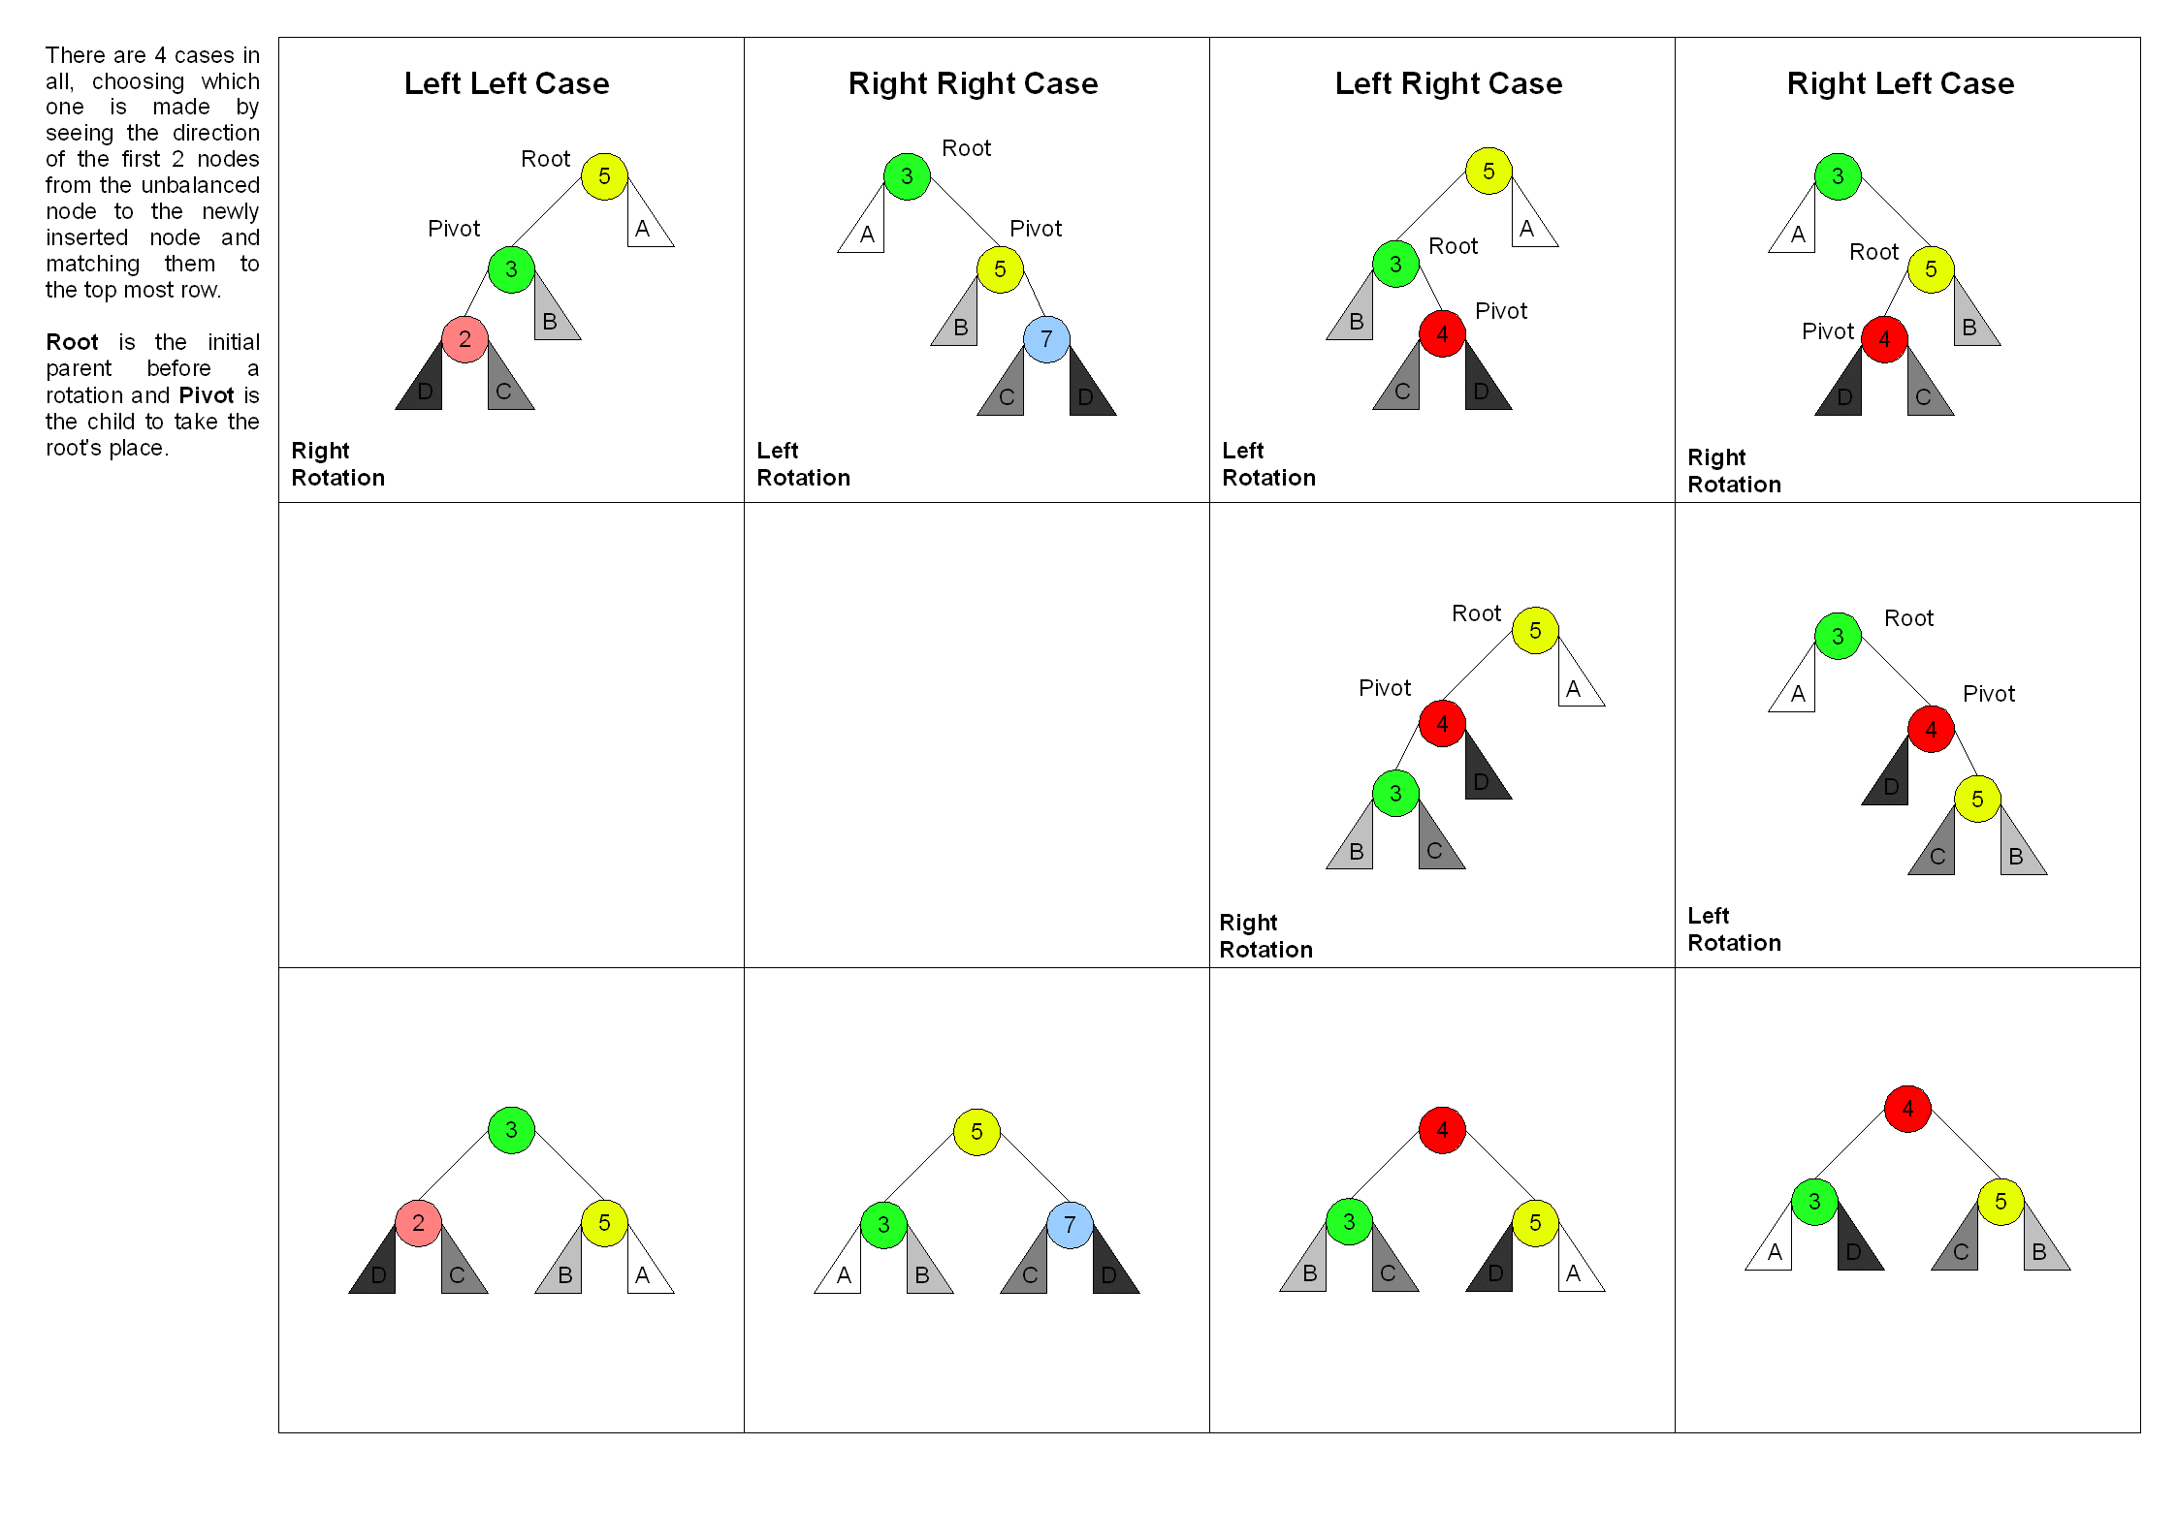

Assignment
Submit your BST (which can only store Strings) with the addBalanced method. The driver is called BST_AVL_Driver.java. The driver gives you several test cases. (Beware! The “5 3 2” is treated as three strings, not as three integers.) The first four test cases allow you to test your code using the nodes on the chart above.

//String line = "5 3 2"; //left-left case (right rotation)
//String line = "3 5 7"; //right-right case (left rotation)
//String line = "5 3 4"; //left-right case (left rotation then
// right rotation)
//String line = "3 5 4"; //right-left case (right rotation then
// left rotation)
//String line = "a b c d e f g";
//String line = "g f e d c b a";

Extensions
- Implement a red-black tree. Look it up on the Internet.
- Removing a node from an AVL tree, then rebalancing, requires a different algorithm because adding always occurs at a leaf, but removing could remove any node in the tree.
- Implement an O(log n) AVL rebalancing algorithm. One implementation adds an extra field to the TreeNode class to store the height of that node. Another implementation uses two parallel trees, one to store the data and the other to store the heights.

